(DFA-OCA-CRD-05 / REV.01 / 24 APRIL 2018)

PHILIPPINE CONSULATE GENERAL, FRANKFURT

ROB-FR- -20

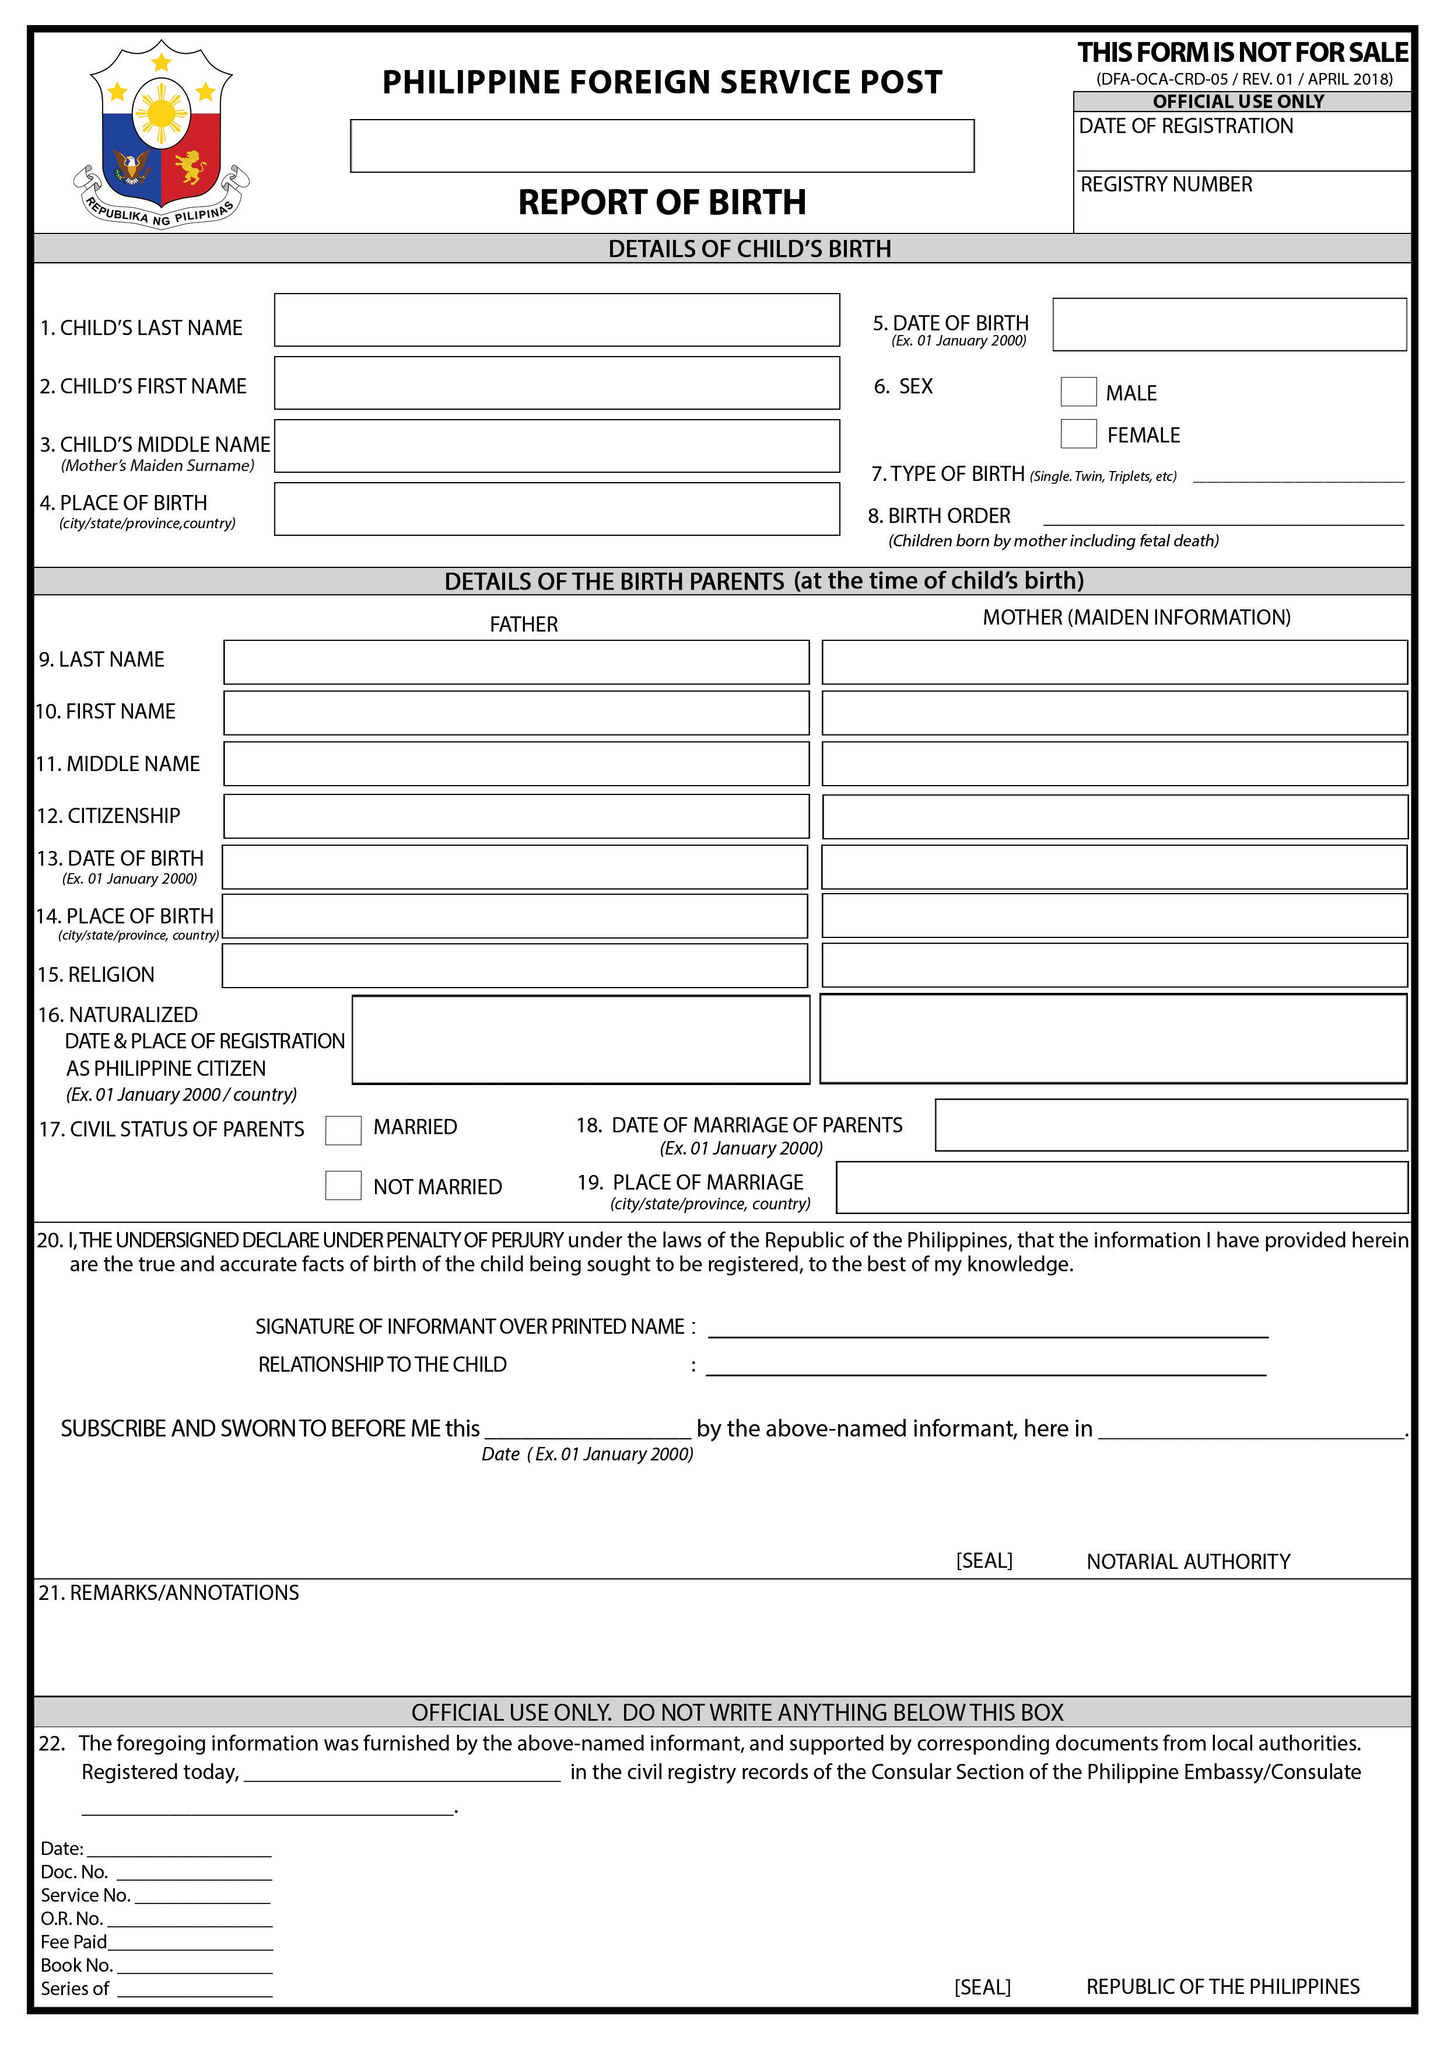

Frankfurt, Germany

ROB-FR- -20

Euro 22,50

20

