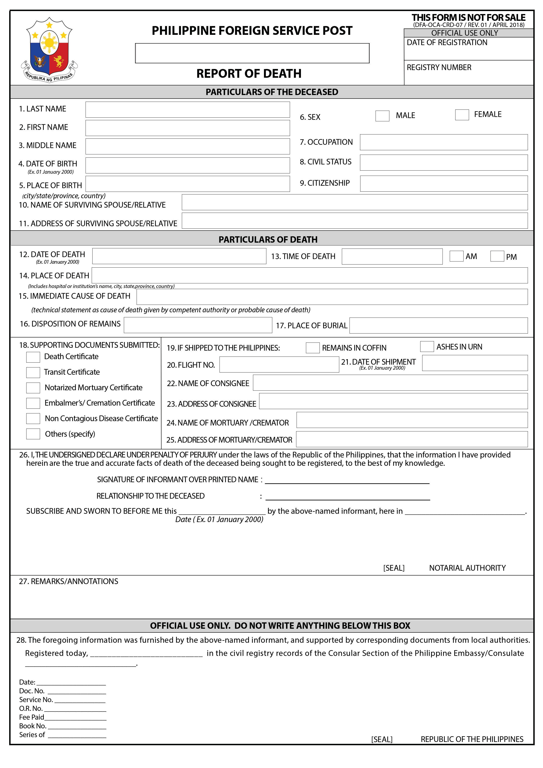 (DFA-OCA-CRD-07 / REV.01 / 24 APRIL 2018)

PHILIPPINE CONSULATE GENERAL, FRANKFURT

ROD-FR- -20

Frankfurt, Germany

ROD-FR- -20

Euro 22,50

