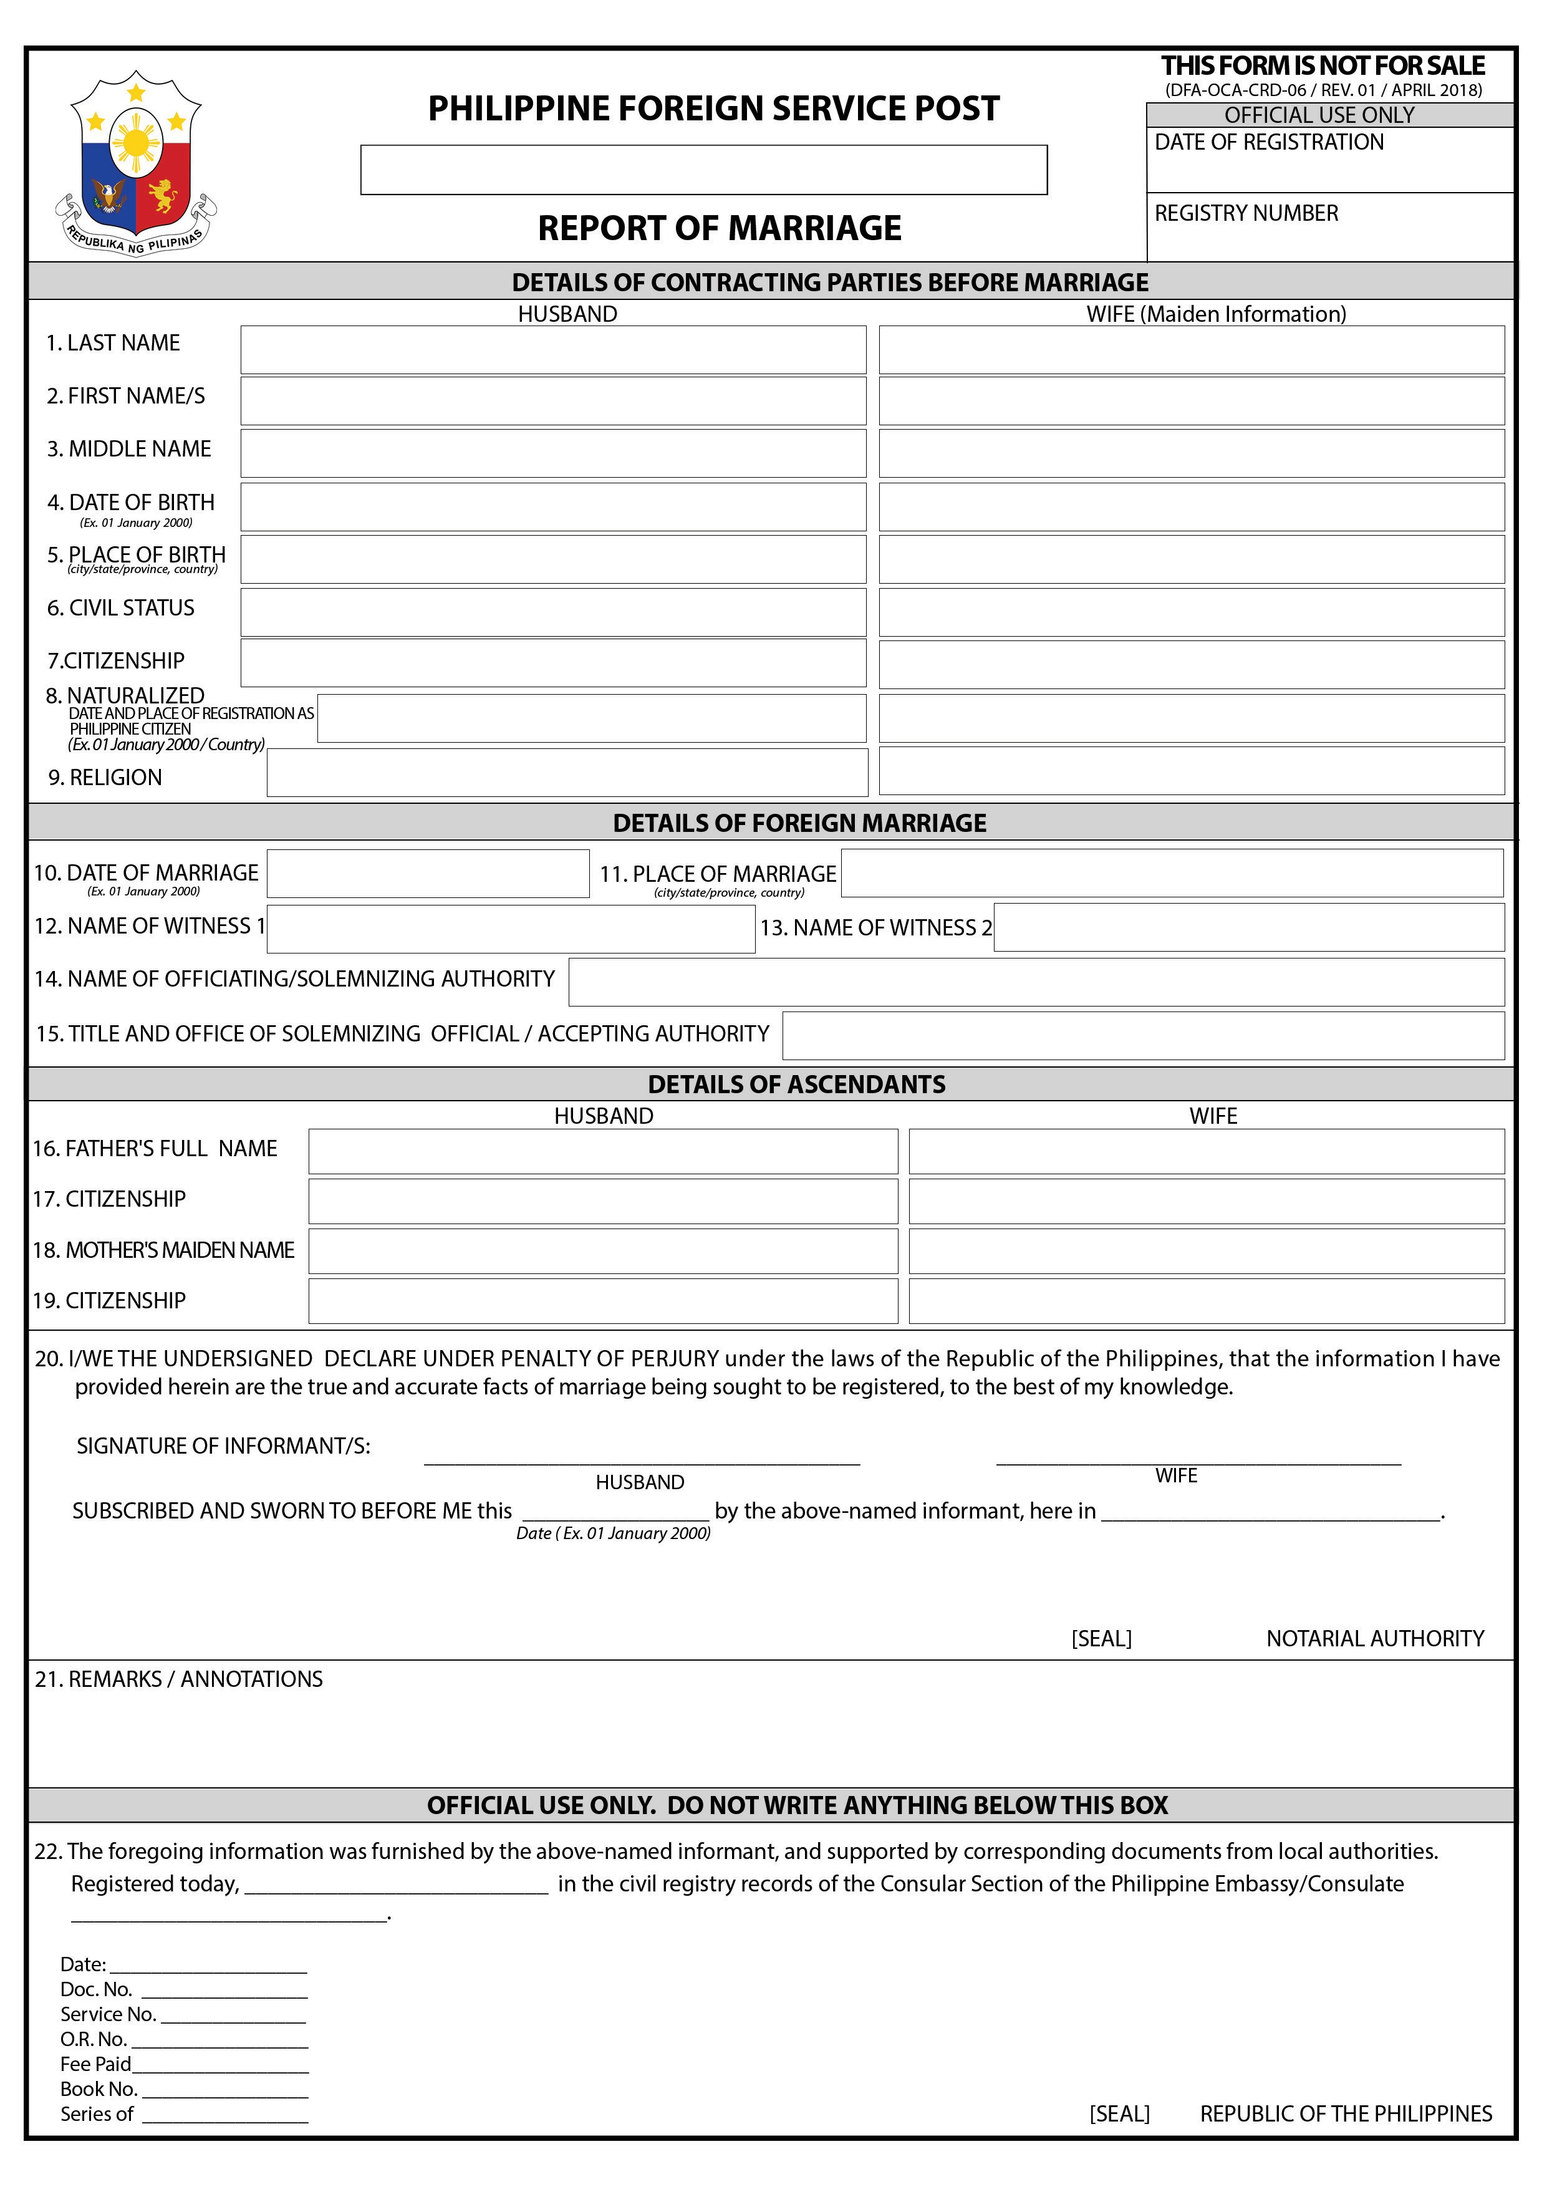

(DFA-OCA-CRD-06 / REV.01 / 24 APRIL 2018)

PHILIPPINE CONSULATE GENERAL, FRANKFURT

ROM-FR- -2019

Frankfurt, Germany

ROM-FR- -2019

22.50 Euro 2019

