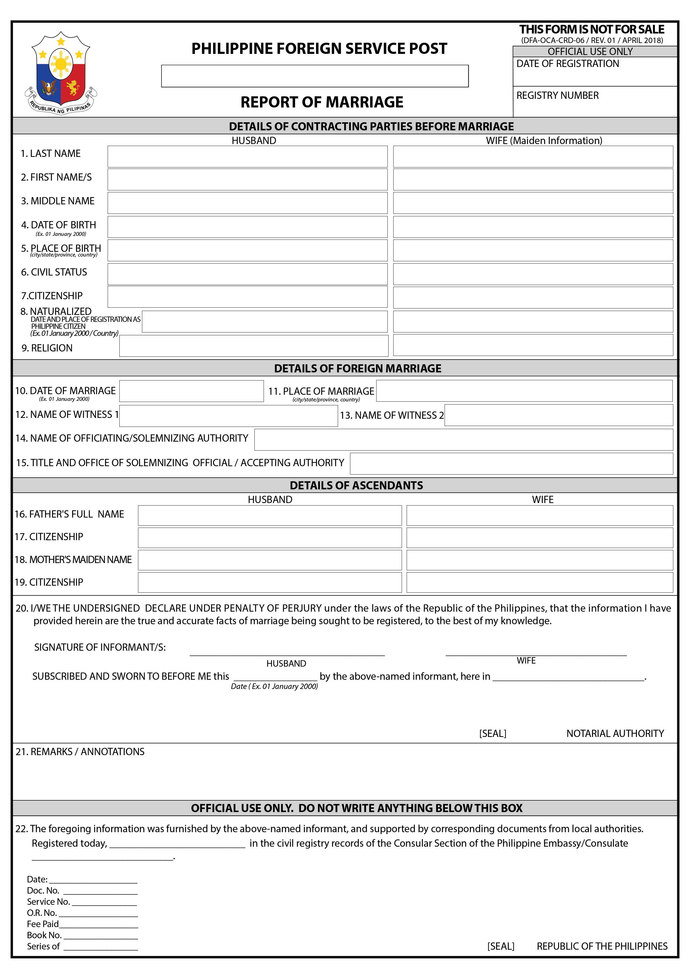

(DFA-OCA-CRD-06 / REV.01 / 24 APRIL 2018)

ROM- -2021

, Germany

ROM- -2021

22.50 Euro 2021

